Figure 1 Below shows all for tables in the database using the select table_name from users_tables command.

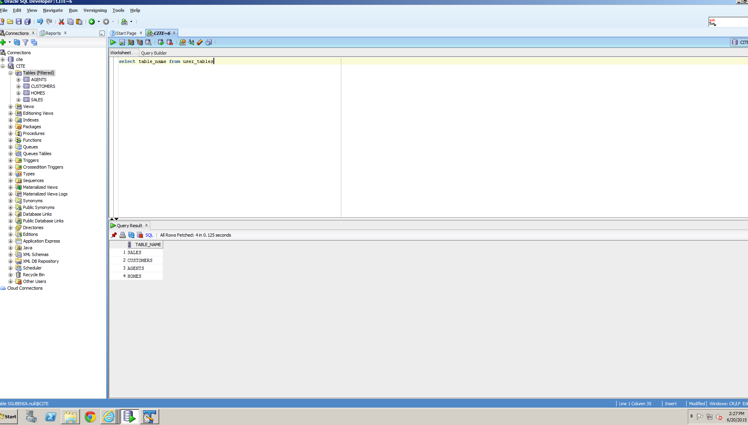

Figure 1 Screen shot of all four tables in the database

Figure 2 shows a description of the agents table using the DESC command as well as all records contained within the table using the SELECT * FROM command.

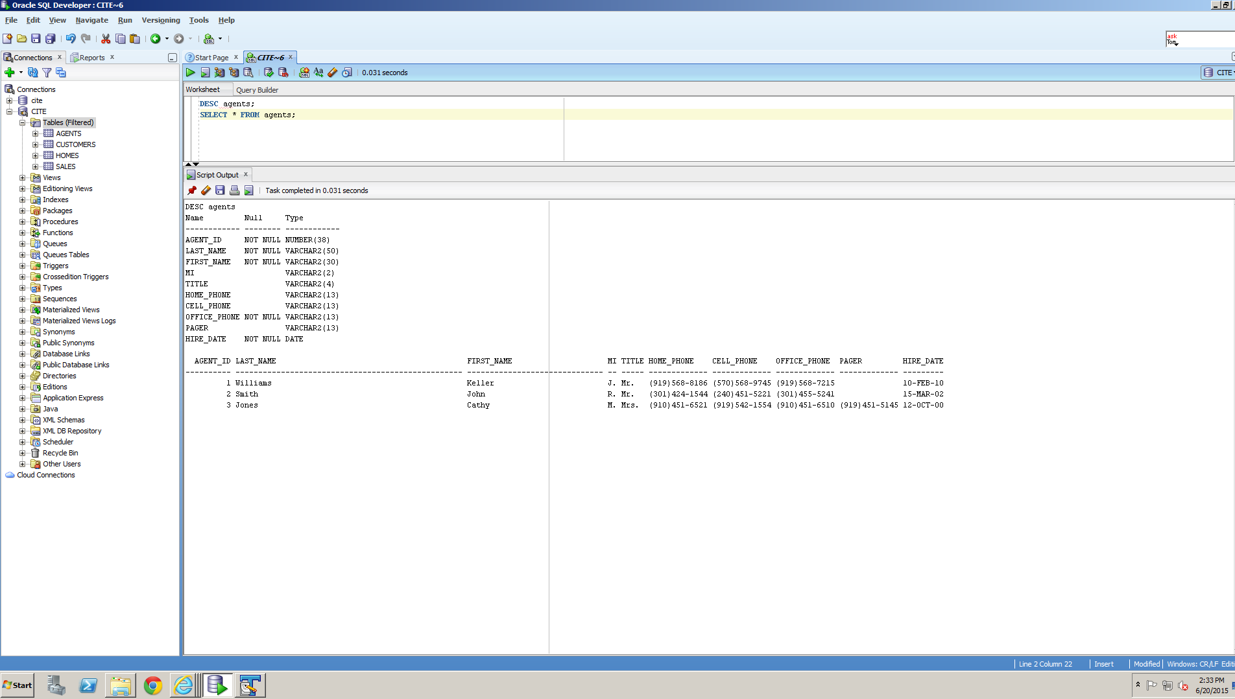

Figure 2 Screen shot of agents table

Figure 3 shows a description of the customers table using the DESC command as well as all records contained within the table using the SELECT * FROM command.

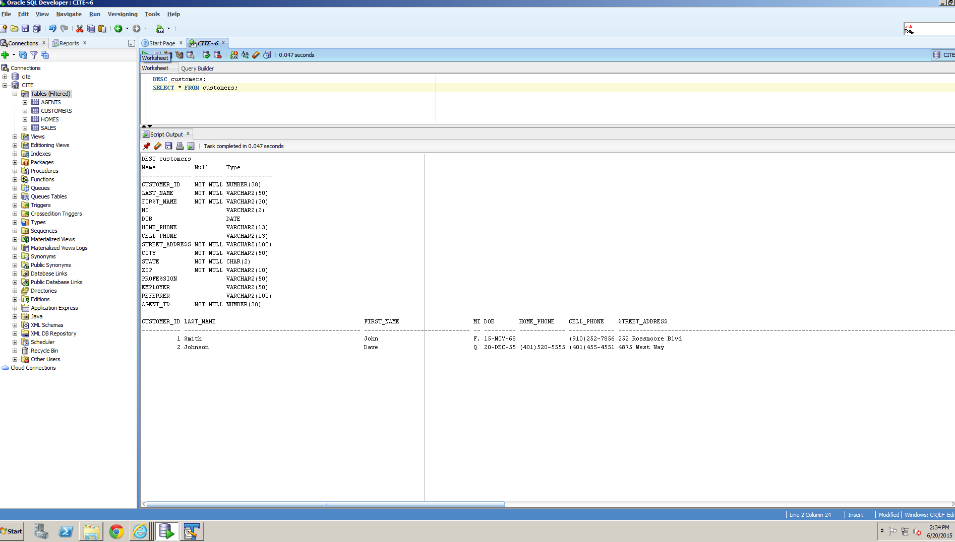

Figure 3 Screen shot of customers table

Figure 4 shows a description of the homes table using the DESC command as well as all records contained within the table using the SELECT * FROM command.

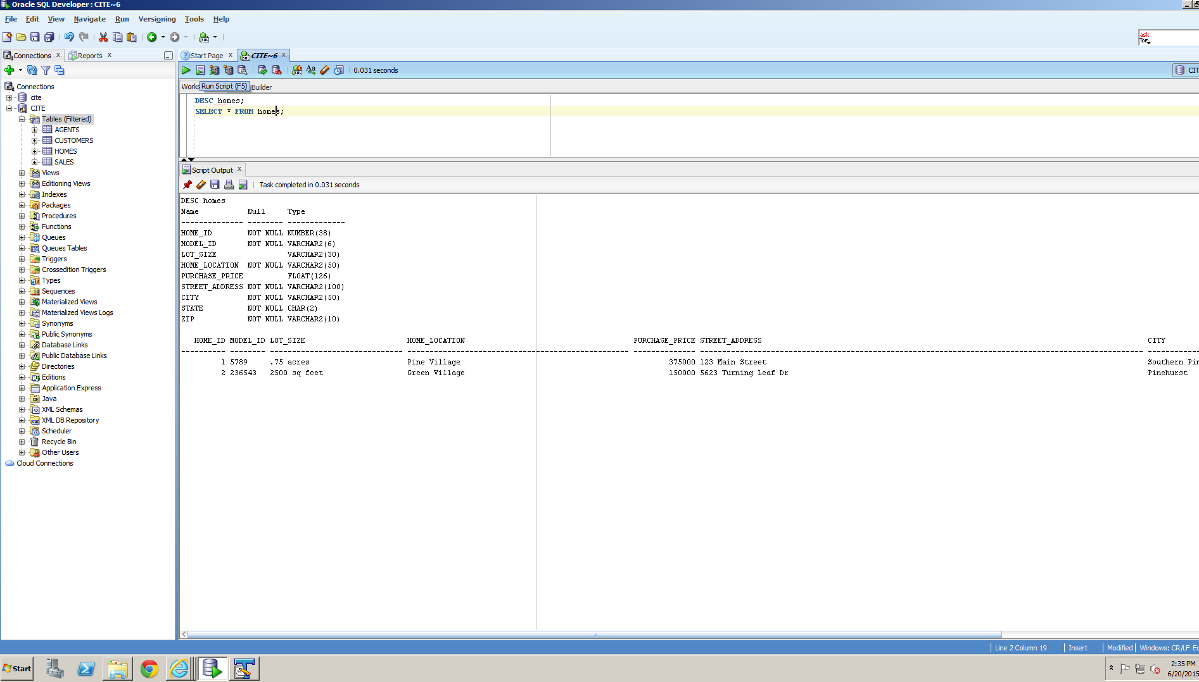

Figure 4 Screen shot of homes table

Figure 5 shows a description of the sales table using the DESC command as well as all records contained within the table using the SELECT * FROM command.

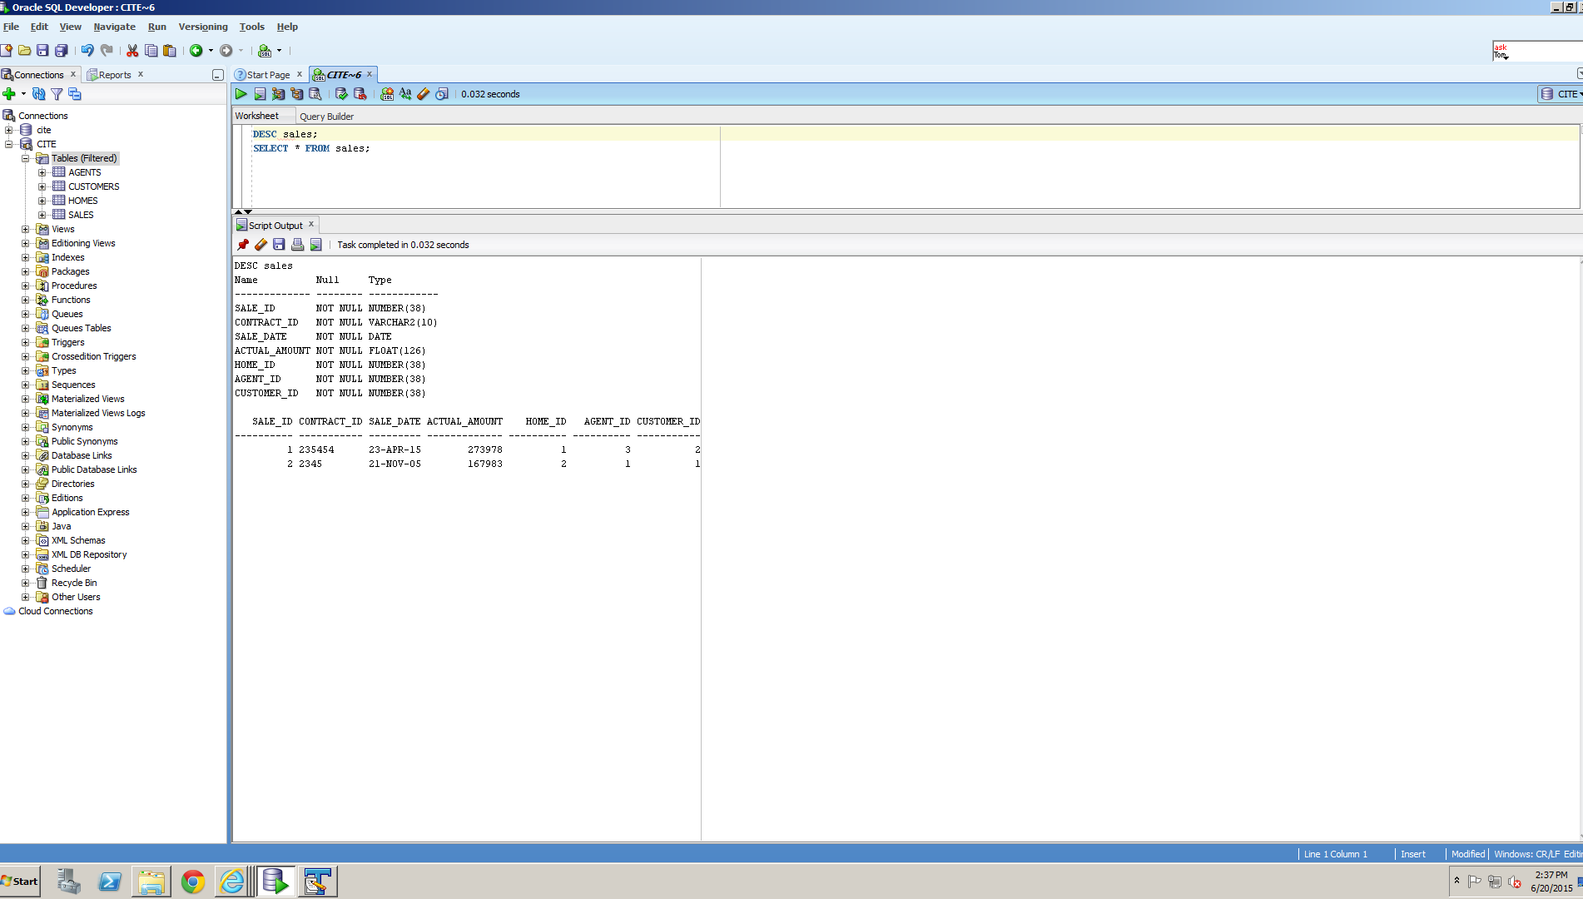

Figure 5 Screen shot of sales table